Regular setup 1:
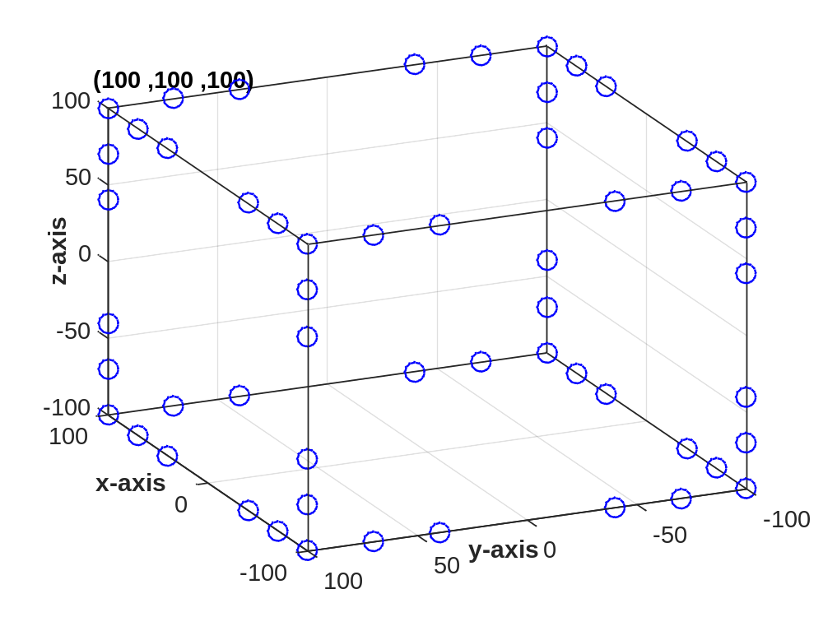
Regular setup 2:

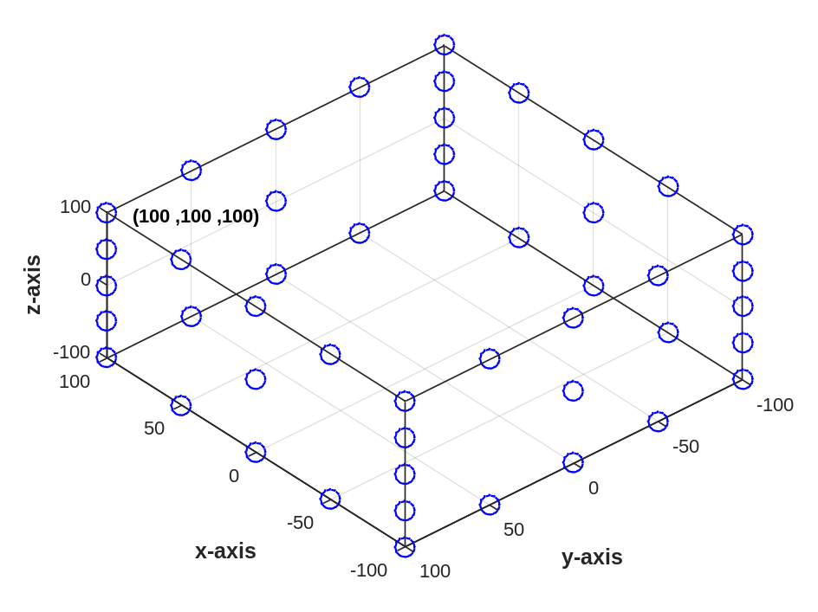

Regular setup 3:
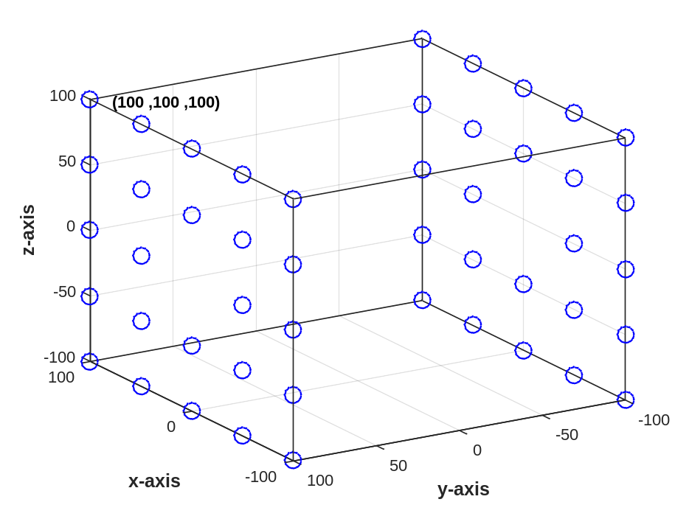

Regular sensor setup 3 (200x200x200) and small intestine (120 x 70 x 120 dimension):
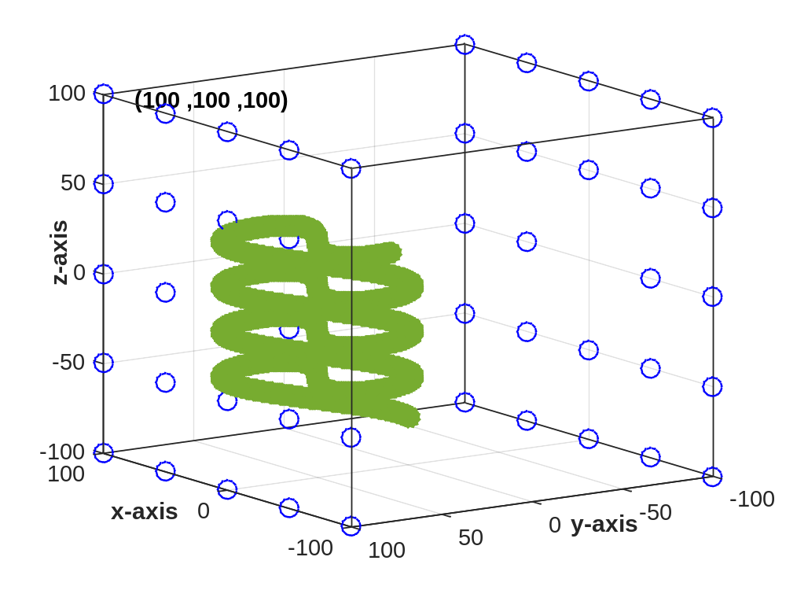
Regular sensor setup 4 (400x400x200) and small intestine (200 x 100 x 200 dimension):
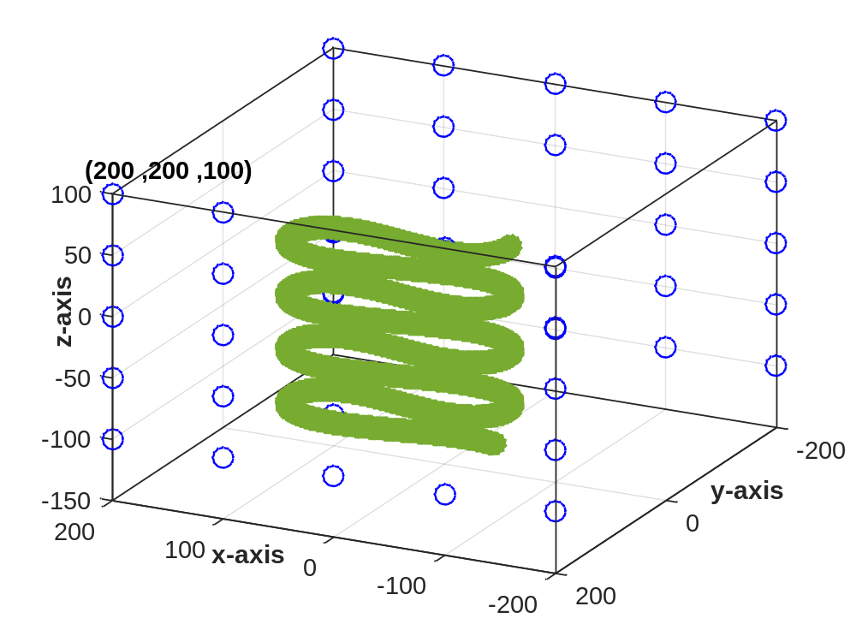
Regular sensor setup 5 (600 x 600 x 200) and small intestine ((200 x 100 x 200 dimension):
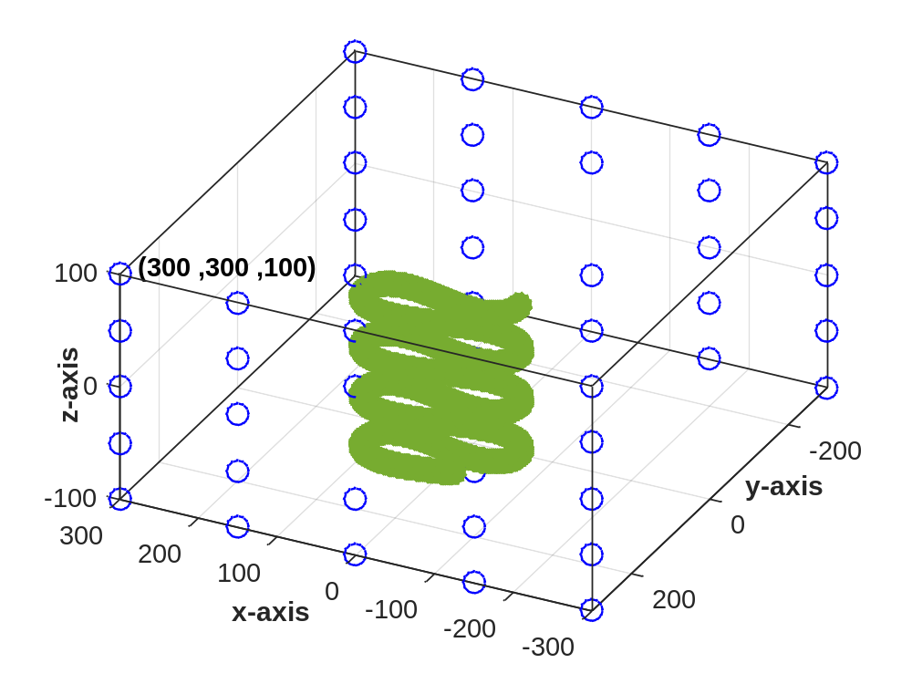
Irregular setup 1:

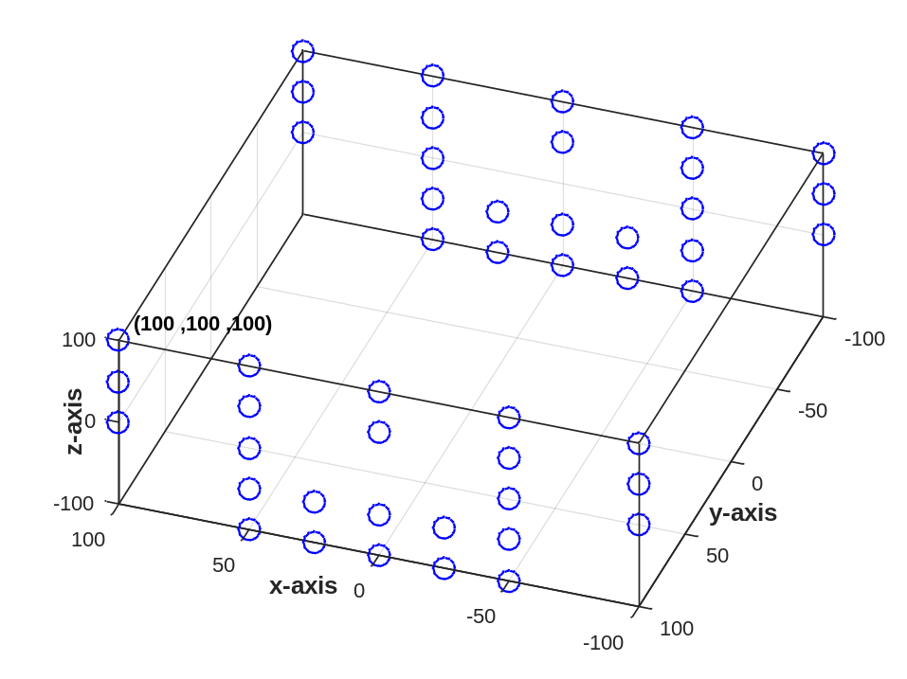
Irregular setup 2:
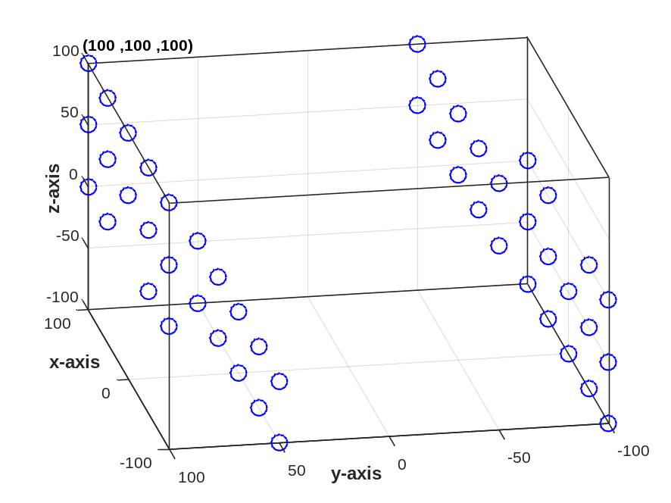

Irregular setup 3:
